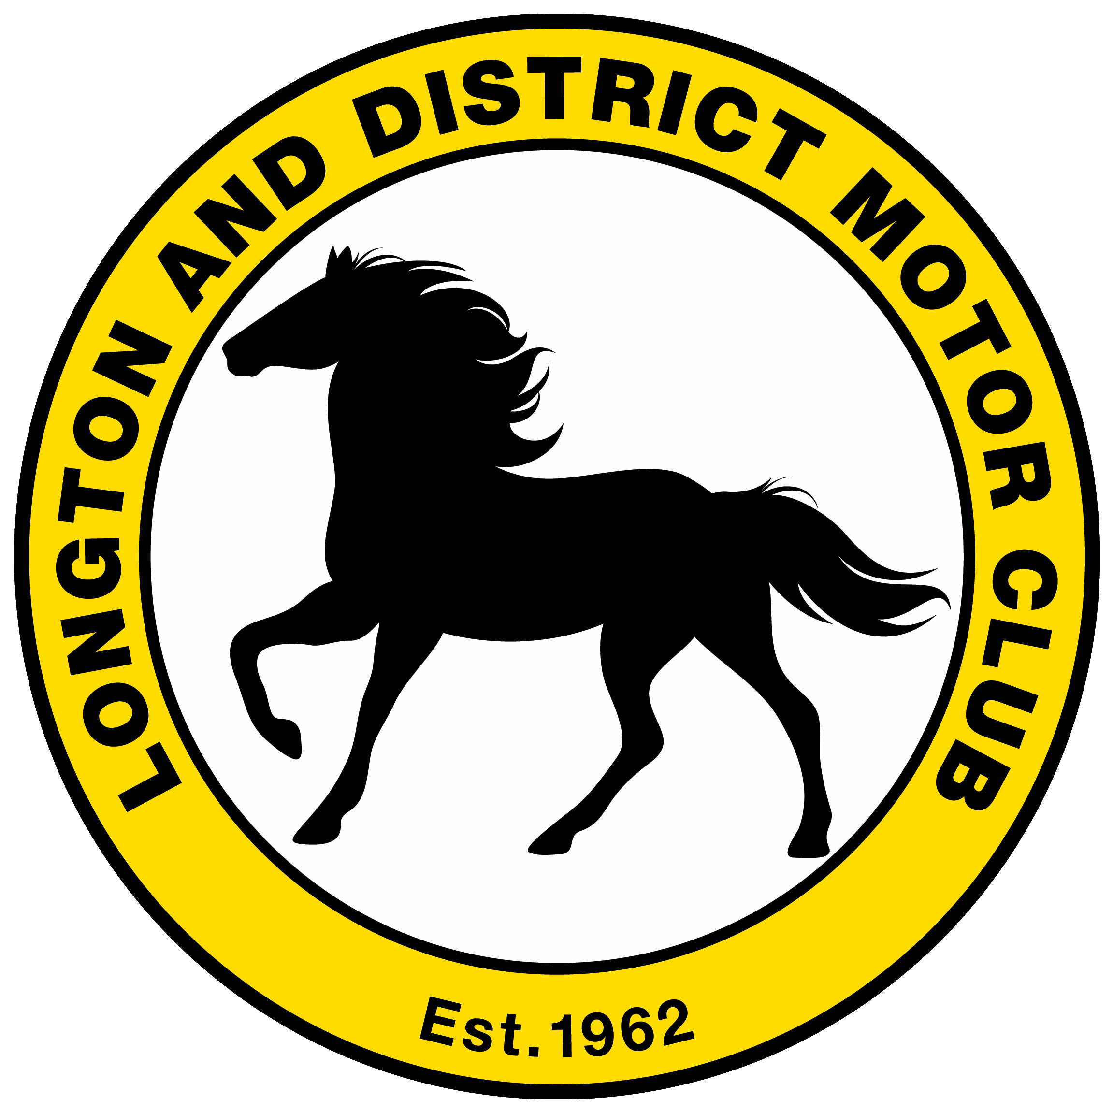

2020 REGISTRATION FORM

LONGTON’S NORTHERN SPEED CHAMPIONSHIP,

LONGTON’S SPRINT SERIES &

LONGTON’S CHAMPION OF THREE SISTERS

Held under the General Regulations of Motorsport UK (incorporating the provisions of the International Sporting Code of the FIA) and the Club’s Supplementary Regulations.

Registration can also be submitted online at www.longton-dmc.co.uk

Please note that all registered contenders must be fully paid up members of Longton & District Motor Club. Please apply or renew your membership on the separate membership form. | Membership No (if known)

DRIVER INFORMATION
First Name |  |  |  | Surname
Gender |  |  |  | Date of Birth *
Address
Town |  |  |  | County
Post Code |  | Email
Tel (day) |  |  |  | Mobile

VEHICLE INFORMATION
Manufacturer |  |  |  | Model / Type
Year |  |  | Vehicle Reg. No | or Not road-going (tick)
Capacity | cc | Engine (if applicable) |  | Turbo / Supercharged / Rotary
Fuel | Petrol / Methanol / Diesel / Other |  |  |  |  | Class

CHAMPIONSHIP CHOICE
Longton’s Northern Speed Championship (£18) | OR |  | Longton’s Sprint Series (£14)
Longton’s Champion of Three Sisters |  | (FREE and open to all LDMC Members)
Championship Stickers required |  | (two will be provided)
T-Shirt Size  (Not applicable for Champion of Three Sisters) |  | S / M / L / XL / XXL / XXXL

* NORTHERN SPEED CHAMPIONSHIP COMPETITORS ONLY *
I wish to register for the Best Novice/Newcomer award | (optional)
I wish to register for the Seniors award | (optional if 60 years or over at 1st Jan 2020)

* SPRINT SERIES COMPETITORS ONLY *
I wish to register for the Young Driver award | (optional if 25 years or younger at 1st Jan 2020)

ADDITIONAL CHAMPIONSHIP T-SHIRTS
You can purchase up to 3 additional t-shirts of each size at £7.50 each. Please indicate the desired numbers below.
Small |  |  | X Large
Medium |  |  | XX Large
Large |  |  | XXX Large

Please continue overleaf for Fee Calculation & Payment details.

FEE CALCULATION
Entry fee for Longton’s Northern Speed Championship = £18  OR  Entry fee for Longton’s Sprint Series = £14 |  |  | £
Additional T-Shirts |  | @ £7.50 each | £
Total |  |  | £

PAYMENT OPTIONS
I wish to pay by cheque and enclose one payable to Longton & District Motor Club
OR | I wish to pay by Credit/Debit Card. (We accept Mastercard, Visa & American Express at no extra cost)
We cannot hold your card details on file, so if you wish to pay by card please provide some information on when is best to contact you.
Signature * (Parent/Guardian if under 18 years old)

- Please ensure the form is fully completed and return to:

- Gavin Leadbetter, LDMC Entries Secretary, 48 Lynton Avenue, Leyland, Lancashire, PR25 4HY
- or scan and email to entries@longton-dmc.co.uk. For assistance, call 07788 885711.

FOR OFFICIAL USE ONLY
Entered in Wufoo | Membership Verified | Cheque No: | Cheque Date:

